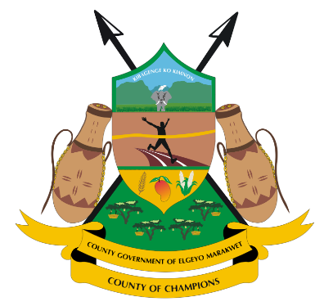

COUNTY GOVERNMENT OF ELGEYO MARAKWET

All Correspondence to be Treasury Building
Addressed to: County Secretary P O BOX 220 – 30700,
Email: countysecretary@elgeyomarakwet.go.ke ITEN.

DEPARTMENT OF HEALTH SERVICES
Department of Health Services Unveils Ward-Centric Health Data to Empower Public Participation
In a groundbreaking move to enhance transparency and public engagement in healthcare planning, the County Government of Elgeyo Marakwet, through the Department of Health Services, has released comprehensive ward-level health data. This strategic initiative marks a significant policy shift by the County Executive Committee Member (CECM) for Health Services, reinforcing the commitment to data-driven decision-making and community involvement as we prepare to launch the County Strategic Plan 2023-2027.
A New Era of Transparency and Public Involvement
The decision to share detailed health data publicly is rooted in the belief that an informed public can actively contribute to shaping the future of healthcare in the county. The released data includes key performance indicators (KPIs) per ward, detailed disease burden information, and tailored strategies to address specific health challenges across different wards.
As the county gears up for the upcoming ward public participation forums, residents will have the opportunity to engage meaningfully with the data, providing valuable input that will inform policy and resource allocation decisions.
Key Health Performance Indicators Per Ward
The data provides a granular look into various health indicators, shedding light on areas of progress and those requiring urgent intervention. Some of the critical indicators covered include:
- Skilled Birth Attendance: A measure of maternal health service uptake, with wards like Tambach performing above county averages, while others show a need for targeted interventions to enhance service delivery.
- Immunization Coverage: A crucial indicator for child health, highlighting disparities across wards and the need for outreach programs to boost coverage, ensuring every child receives life-saving vaccines.
- Malaria Incidence: Wards with high malaria burden, such as Arror, require focused control efforts, including vector management, distribution of insecticide-treated nets, and improved access to treatment.
- Teenage Pregnancy Rates: An area of concern in several wards, necessitating comprehensive reproductive health interventions, community awareness campaigns, and adolescent-friendly services.
- Health Insurance Coverage: Low coverage rates in some wards underscore the need for intensified SHA/SHIF enrolment drives and sensitization efforts to promote access to affordable healthcare.
Detailed Disease Burden Information
The ward-level data highlights the prevalence of various health conditions, enabling targeted responses. Key disease burden insights include:
- Communicable Diseases: High incidences of diarrheal diseases, malaria, and respiratory infections in specific wards, necessitating robust preventive and curative interventions.
- Non-Communicable Diseases (NCDs): Rising cases of hypertension and diabetes emphasize the need for lifestyle interventions, regular screening, and patient education on risk factors.
- Eye and Dental Health: High morbidity rates in some wards call for specialized clinics, increased access to diagnostic services, and mobile outreach programs.
- Nutrition Status: The data highlights malnutrition trends, informing targeted nutrition programs aimed at addressing stunting, wasting, and micronutrient deficiencies.
Health Improvement Strategies
Based on the data insights, the county has outlined comprehensive interventions to each ward to improve health outcomes, including:
- Infrastructure Development: Construction and renovation of dispensaries, outpatient departments (OPD), staff housing, and improved water and sanitation facilities to ensure quality service delivery.
- Healthcare Workforce Support: Recruitment of health interns, capacity-building programs, and performance-based incentives for Community Health Volunteers (CHVs) to strengthen service delivery at the grassroots level.
- Emergency and Referral Services: Procurement of ambulances, establishment of an Emergency Transfer Centre, and strengthening referral networks to improve response times and patient outcomes.
- Public Health Interventions: Investments in nutrition programs, reproductive health outreaches, maternal and child health services, and health promotion initiatives.
- Health Information Systems: Automation of health facilities to enhance service delivery, data management, and evidence-based planning.
- Community Engagement: Strengthening partnerships with local communities and stakeholders to ensure inclusive health planning and accountability.
Call to Action: Participate and Shape Our Healthy Future
Residents of Elgeyo Marakwet are encouraged to actively participate in the upcoming ward public participation forums to discuss these findings and provide feedback. Your input will play a crucial role in shaping the county's healthcare priorities for the next five years.
Stay informed and engaged as we work together to build a healthier Elgeyo Marakwet County.
For more information, visit our official website or contact your local health facility.
https://elgeyomarakwet.go.ke/publications/

Participation link is https://echo.zoom.us/j/82183094177.

